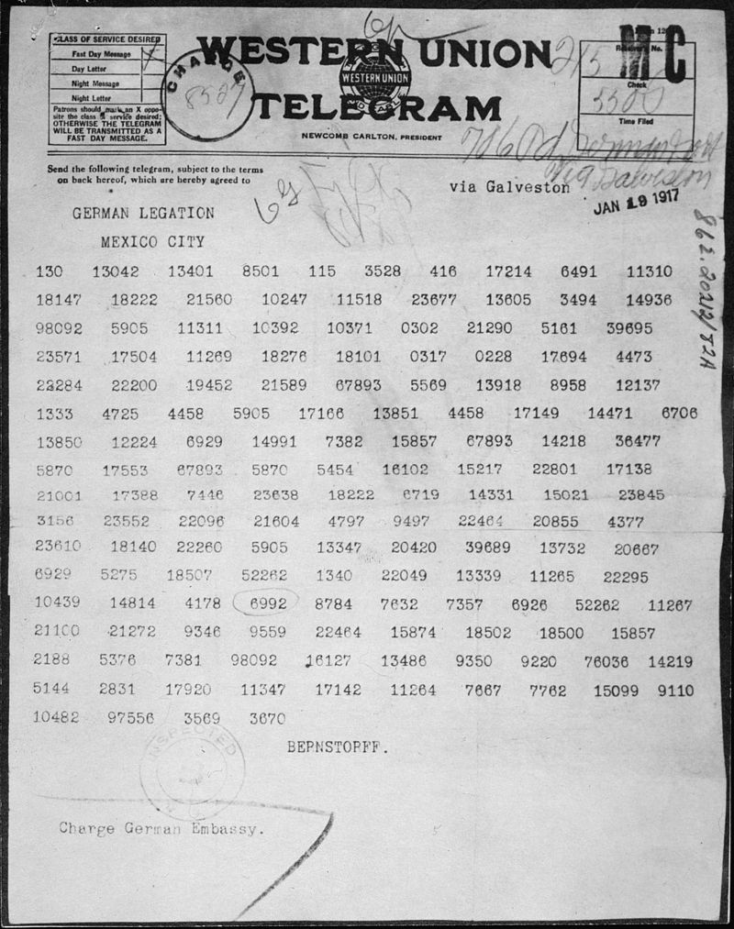

The War to End War – 1917-1918
“Destiny dealt cruelly with __________ _____________. The lover of peace, as fate would have it, was forced to lead a hesitant and peace-loving nation into _________.”
“Germany’s warlords responded with a blow of the mailed fist. On _____________________ they announced to an astonished world their decision to wage _______________ _____________ ____________, sinking all ships, including America’s, in the war zone.”
War by Act of Germany
“Meanwhile, the sensational ________________ ________ was intercepted and published on March 1, 1917, infuriating Americans, especially westerners, German foreign secretary _________ _________________ had secretly proposed a German-Mexican alliance, tempting anti-Yankee Mexico with veiled promises of recovering _______, ___________, and ___________.””
“Subdued and solemn, Wilson at last stood before a hushed joint session of Congress on the evening of ______________, and asked for a ____________ ____ ______________.”
Wilsonian Idealism Enthroned “It is a _________ _______ to lead this great peaceful people into war,” Wilson said in his war message.
Creel Manipulates Minds
“Mobilizing people’s minds for war, both in American and abroad, was an urgent task facing the Washington authorities. For this purpose the _____________________ _____ ________ _________________ ________________was created.”
“It sent out an army of _____________ “_______ _____________ _________”- often longer winded than that- who delivered…patriotic pep.”
Enforcing Loyalty and Stifling Dissent
“Both the _________ ______ of 1917 and the _______________ _________ of 1918 reflected current fears about Germans and antiwar Americans.”
“But in Schenck v. United States (1919) the Supreme Court affirmed their legality, arguing that ____________ ____ ______________ could be revoked when such speech posed a “_______ ____ _________ ___________” to the nation.
The Nation’s Factories go to War
“Although the War Industries Board had only feeble formal powers, it set a precedent for the ________ _____________ to take a central role in ___________ _____________ in moments of crisis.”
Suffering until Suffrage
“In 1920, more than __________ _________ after the first calls for suffrage at Seneca Falls, the _________ ___________ was ratified, giving all American women the right to vote.”
Forging a War Economy
“Many leading brewers were German-descended, and this taint made the drive against alcohol all the more popular. The reformers dream of a _______________ nation was finally achieved—temporarily—in 1919 with the passage of the ________ Amendment, prohibiting ____________ _____________ ________________.”
“Farm production increased by ______________ and food exports to the Allies _____________ in volume.” “The Fuel Administration exhorted Americans to save fuel with “__________ ___________, __________ ______________ and _________________ _______________.” The ultimate bill mounted to some ________________.
Making Plowboys into Doughboys
“The draft act required the registration of all males between the ages of ____ and __________.” “Within a few frantic months, the army grew to over ______ million men.”
“Not surprisingly, American soldiers suffered from high rates of ______________ _____________.”
“American operations were not confined solely to ________; small detachments fought inn __________, Italy, and notably ___________. …Wilson likewise sent nearly ____________ troops to _____________...”
America Helps Hammer the Hun
“Newly arrived American troops, numbering fewer than thirty thousand, were thrown into the breach at ________ __________________ right in the teeth of the German advance.”
“As part of the last mighty Allied assault, involving several million men, Pershing’s army undertook the ________ _____________________________ _______________, from September 26 to November 11, 1918.”
“___________ _____________, containing seductive Wilsonian promises, rained down upon their crumbling lines from ___________, shells and ______________.”
The Fourteen Points Disarm Germany
“Berlin was now ready to hoist the ___________ flag.” “They laid down their arms at ________ o’clock on the _____________ day of the ___________ month of 1918…”
“But the costs exceeded comprehension: nearly ___ million soldiers had died, and more than _____ million had suffered grievous wounds. To make matters worse, some _____ million people perished in a worldwide _______________ pandemic in 1918-1919. Over ______________ Americans, more than ____ times the number of U.S. combat casualties- died from the _____.”
An Idealist Amid the Imperialists
“Wilson’s ultimate goal was a world parliament to be known as the _______________ ________ _________________.”
The Peace Treaty that Bred a New War
“A completed ____________ _______ _________________, after more weeks of wrangling, was handed to the Germans in June 1919—almost literally on the point of a ____________________.”
The Betrayal of Great Expectations
“America’s spurning of the ____________ was tragically ___________ __________________.”
“In the interests of it’s own security, if for no other reason, then United States should have used its enormous strength to shape ______________________________________. Instead it permitted itself blithely to drift toward the ________ of a second and even more _______________ ______________________________ ___________________________.”
Next- Watch the Crash Course- pick five things you learn or are reminded of that weren’t in the AP Text:
1
2
3
4
5

