The Impact of WWII on Americans

1. Introduction
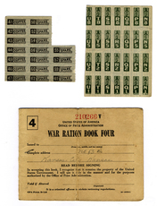
After the shock of the Pearl Harbor attack, many Americans wondered what would happen next. Would waves of Japanese bombers attack the West Coast? For months, rumors of an enemy invasion haunted the region. In time, the fears faded, but coastal communities remained wary.

As it turned out, the United States was not immediately endangered by an enemy invasion. Yet, as President Franklin Roosevelt warned, the threat was real. If the Allies failed to stop the Axis powers, then one day Americans could personally experience the horrors of war in their own land.
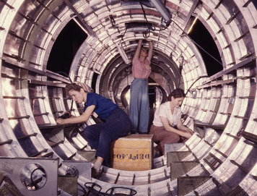
Roosevelt knew the war effort would require the enthusiastic backing of the American people in order to succeed. Millions of Americans would be needed to serve in the armed forces. Many others would help on the home front by working to expand the output of war materials. Everyone would have to make sacrifices in support of the armed forces. They would have to accept rationing—a system for limiting the distribution of food, gasoline, and other goods—so the military could have the weapons, equipment, and supplies it needed. As a result, life in the United States would change dramatically.
These changes were evident in many ways, even in clothing styles. The armed forces needed fabric for uniforms. In March 1942, the government announced rules aimed at saving more than 40 million pounds of wool a year. Men's suits could no longer be sold with a vest or an extra pair of pants. Cuffs were eliminated, as were patch pockets and wide lapels. The new rules also restricted the type and amount of fabric in women's clothes. Designers cooperated by using more synthetics, such as rayon, and by making skirts shorter and dresses simpler.
During the war, the entire country would endure hardships, many extending far beyond being forced to wear plainer clothes. Yet the war would also offer new opportunities to countless Americans.

2. Organizing the American Economy for War
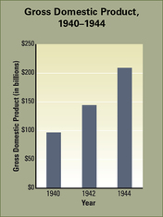
The job of organizing the wartime economy fell to the War Production Board (WPB). The WPB sought to meet Roosevelt's goal of making the United States the “arsenal of democracy.” As with the War Industries Board of World War I, the WPB's main task was to manage the conversion of industries to military production. Some of these makeovers seemed natural. Automobile manufacturers, for example, switched from making car engines to making airplane and tank engines. Other conversions called for more dramatic changes. For example, a soft drink company might retool its machinery and retrain its workers to pack artillery shells with explosives.A maker of model trains would begin producing bomb fuses. All across the country, businesses mobilized their resources to serve the needs of the military.

A Wartime Production Boom Ends the Depression The huge demand for military supplies revived the economy. Businesses expanded and hired more workers. Farmers prospered as crop prices and farm incomes rose. The Depression ended, and a period of vigorous economic growth began.
As the economy moved into high gear, the gross domestic product (GDP) rose rapidly. GDP is the total value of goods and services produced in a country in a year. From 1940 to 1944, this basic measure of national output increased by 116 percent. During the same four years, the total personal income of American workers rose by more than 110 percent. Business income grew even faster, increasing by nearly 130 percent.
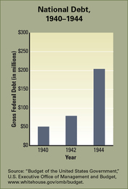
During the New Deal, the government had taken an active role in stimulating the economy. To meet wartime needs, it expanded that role. The WPB successfully mobilized businesses behind the war effort, leading to closer relationships between the government and large corporations. As also happened during World War I, a National War Labor Board (NWLB) was set up to mobilize labor.
The main task of the NWLB was to settle labor disputes before they disrupted the production of war goods. Immediately after the attack on Pearl Harbor, union leaders agreed to a no-strike pledge. Eight months later, the NWLB imposed limits on wage increases.The wage limits and no-strike pledge left labor leaders with very little bargaining power. In exchange, the NWLB guaranteed unions that all new employees at companies with union contracts would automatically become union members. This policy boosted union membership.

Financing the War Effort with Taxes and Bonds During the war, government spending rose to new levels. More than $175 billion worth of defense contracts went out to businesses from 1940 to 1944. The government met these costs the same way it had during World War I—through taxes and borrowing.
Taxes provided about 45 percent of the revenue needed to pay for the war. The Revenue Act of 1942 increased individual and corporate income tax rates and more than tripled the number of individuals required to pay income tax. To make tax collection easier, Congress devised a system of withholding. Employers held back a certain amount from every paycheck and sent it directly to the government. This system of payroll taxes is still in place today.
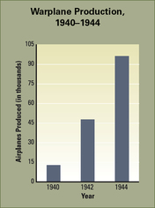
Borrowing provided much of the rest of the money to finance the war. The government borrowed from banks and other financial institutions. It also borrowed from the American people through the sale of war savings bonds. As during World War I, war bonds not only provided the government with cash but also gave people a way to show their support for the war effort. Government agencies and private companies once again produced advertisements urging Americans to buy war bonds. Campaigns to sell bonds involved a variety of Americans, from schoolchildren to glamorous celebrities.

Government Attempts to Curb Inflation and Consumption Inflation became a serious problem during the war. Americans had money to spend, but the focus on military production meant that few consumer goods were available. In a fireside chat, Roosevelt explained the supply-and-demand problem: “You do not have to be a professor of mathematics or economics to see that if people with plenty of cash start bidding against each other for scarce goods, the price of those goods goes up.”
Congress gave the job of curbing inflation to the Office of Price Administration. The OPA instituted price controls—a system of legal restrictions on the prices charged for goods. These controls seemed to work. From 1940 to 1945, consumer prices rose only 35 percent, instead of doubling or tripling as some officials had feared.
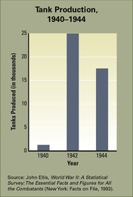
The OPA also rationed about 20 basic consumer products, including gasoline, tires, sugar, meats, and processed foods. Each month, consumers received books of coupons that they turned in to the grocer when they bought rationed foods. When they ran out of coupons, they could buy no more until they received a new book the next month. Drivers used a different ration book to purchase gasoline. Americans grumbled about rationing, but most complied. This program succeeded in reducing the overconsumption of scarce goods and ensured that everyone would have fairly equal access to those goods.
Americans also aided the war effort in other ways. They formed car pools or rode bicycles to work. They recycled metals, paper, rubber, and other materials. One old shovel, Americans were told, contained enough iron to make four hand grenades. Children collected much of the scrap material. They also peeled the foil off cigarette packages and gum wrappers and rolled them into balls for recycling. Families also planted victory gardens to grow food. In 1943, more than 20 million gardens yielded one third of all the vegetables eaten in the country that year. Victory gardens and recycling campaigns not only boosted war production but also raised the morale of Americans on the home front. People understood they were making an important contribution to the war effort.

3. The Internment of Japanese Americans

When the attack on Pearl Harbor occurred, there were about 150,000 Japanese Americans living in the Hawaiian Islands. Some people questioned their loyalty, even accusing them of helping plan the surprise attack. Fearing sabotage, the War Department recommended the mass evacuation of Japanese Americans from Hawaii. But the American military governor of Hawaii urged everyone to stay calm. Businesses on the islands opposed evacuation. They noted that losing so many workers would ruin the islands' economy. The press backed this position and worked hard to keep false rumors from circulating. In the end, nearly all of the Japanese Americans in Hawaii stayed there.
Dealing with the Fear of Potential Collaborators On the mainland, concerns about disloyalty extended to people of German or Italian ancestry. They were seen as potential collaborators—people who work with an enemy to undermine a nation's security.Shortly after the Pearl Harbor attack, President Roosevelt signed proclamations declaring all German, Italian, and Japanese nationals, or non-U.S. citizens, to be “enemy aliens.” These orders affected more than 314,000 people of German ancestry, 690,000 people of Italian ancestry, and 47,000 people of Japanese ancestry.
All “enemy aliens” had to register with the government and carry special identification cards. They had to turn in all firearms and cameras, as well as shortwave radios, which might be used to send information to the enemy. They also needed a travel permit to go more than 5 miles from their homes.
Government officials considered putting all “enemy aliens” into camps. However, the task of relocating all the German and Italian aliens posed huge problems. Also, politically influential groups of German Americans and Italian Americans resisted such a measure. The government did round up several thousand German and Italian aliens and sent them to internment camps in the middle of the country. An internment camp is a center for confining people who have been relocated for reasons of national security.

Roosevelt Authorizes the Removal of Japanese Americans The people of Japanese ancestry, in contrast, were a much smaller group with much less political power. They faced more racial discrimination than did people of German or Italian ancestry because they were of nonwhite, non-European ancestry. Their social isolation also worked against them. They had not assimilated into American culture as well as other immigrant groups had. They kept largely to themselves, in ethnic communities outside the American mainstream. In addition, they lived mainly on the West Coast, where fear of a Japanese invasion was strongest. Unlike in Hawaii, the mainland press whipped up that fear by accusing Japanese Americans of spying or of being more loyal to Japan than to the United States.
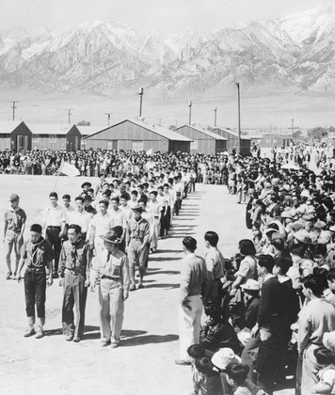
All these factors made it easier for the government to act against people of Japanese ancestry. In February 1942, Roosevelt issued Executive Order 9066. This order declared that large military zones could be set up to exclude current residents who were believed to be a threat to security. In March 1942, the military used this executive order to launch a mass evacuation of people of Japanese ancestry from the Pacific Coast. Evacuees had just a few weeks to sell their homes and possessions.

The order to “move out and stay out” applied not only to Japanese “enemy aliens” but also to Japanese American citizens. Of the 127,000 people of Japanese ancestry living in the mainland United States, 80,000 were native-born American citizens. As such, they were entitled to the same constitutional rights as all citizens. This was the main argument made by a Japanese American named Fred Korematsu, who did not obey the order because it would mean leaving his non-Japanese girlfriend. After two months, Korematsu was arrested and convicted with remaining in a restricted military area.

Korematsu appealed the verdict all the way to the Supreme Court. In the case Korematsu vs United States, the Court upheld his conviction on the grounds that a group's civil rights can be set aside in a time of war. Three of the nine justices dissented from this opinion, including Justice Robert H. Jackson. He expressed his fear that “the Court for all time has validated the principle of racial discrimination in criminal procedure and of transplanting American citizens.”
Life in the Internment Camps More than 100,000 Japanese “enemy aliens” and Japanese American citizens were forced to evacuate. Families collected their belongings in a few pieces of luggage and left their homes. First they gathered at assembly centers. Then, in the summer of 1942, they boarded trains for internment camps scattered throughout the western states. They had no idea where they were headed. The typical camp, officially known as a relocation center, was in a desert region far from any town. “No houses were in sight,” one internee recalled. “No trees or anything green—only scrubby sagebrush and an occasional low cactus, and mostly dry, baked earth.” In this setting, internees endured extreme heat in the summer and cold in the winter.
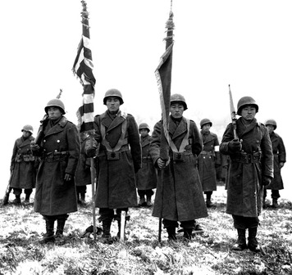
The camps had been constructed in a hurry. They consisted of “row after row of barracks,” as one surprised visitor recalled, with “high barbed wire fences” and “machine gun towers all around.” The single-story, wooden barracks contained several one-room apartments. Each came with cots, blankets, and a bare light bulb. Here, an entire family tried to make a home. They shared toilets with others in the barracks and used common bathing and dining facilities. The crowded conditions meant that sanitation was often a problem.
Despite these hardships, most of the internees worked to make camp life more bearable. They built chairs and tables from scrap lumber. They grew vegetables. They set up schools, libraries, hospitals, and newspaper offices.
As early as 1942, while the camps were still filling up, the government realized that the threat of a West Coast invasion had passed. Officials began allowing certain groups of Japanese Americans to leave the camps. These included about 10,000 farm workers and 4,300 college students. Starting in 1943, thousands of young men left the camps to join the army. Most of them served in the 442nd Regimental Combat Team. This all-volunteer Japanese American unit became famous for its bravery in battle. In fact, it earned more medals than any other unit of its size in American history. In 1944, the government began letting the remaining internees return to the West Coast. Within the next year, all were free to leave the camps.

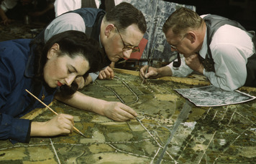
4. Women at War
In early 1942, a popular song called “Rosie the Riveter” captured the spirit of the home front:
All the day long,
Whether rain or shine,
She's a part of the assembly line.
She's making history,
Working for victory,
Rosie the Riveter.
—“Rosie the Riveter,” by Redd Evans and John Jacob Loeb, 1942
One of the country's most popular artists, Norman Rockwell, put his own version of Rosie on the cover of a national magazine, The Saturday Evening Post. Two films about Rosie followed. The fictional Rosie the Riveter came to represent all the real women who worked to support the war effort.

New Opportunities for Women in the Workforce The demand for workers skyrocketed during the war, as men left their jobs to serve in the armed forces. At first, industry hired unemployed men to fill those jobs. But as war production soared, businesses and the government started recruiting women, using slogans such as, “The more women at work, the sooner we win!” About 18 million women took jobs outside the home during the war, up from 12 million before the war.
Most women continued to work in occupations that were traditionally female, such as service, clerical, and sales work. Many women, however, took positions held traditionally by men. They became welders, mechanics, and lumberjacks, as well as lawyers, physicists, and architects.
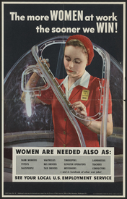
Nearly 2 million women worked in shipyards and other heavy industries. Many toiled as riveters on the thousands of airplanes built during the war. Riveters operated in pairs. One woman used a heavy mechanical gun to shoot a rivet through a pair of metal sheets.The other woman stood on the opposite side to buck, or flatten, the rivet. The rivets held the metal sheets and the plane together.Tough physical labor like this increased women's self-confidence and independence, as well as their income. As one riveter explained,
“The war years had a tremendous impact on women. I know for myself it was the first time I had a chance to get out of the kitchen and work in industry and make a few bucks . . . You came out to California, put on your pants, and took your lunch pail to a man's job . . . This was the beginning of women's feeling that they could do something more.”
—Sybil Lewis, quoted in The Homefront: America During World War II, 1984
Hardships on the Job and at Home Not everything about the workplace pleased women, though. They often faced hostility on the job, especially in male-dominated industries. African American women faced the added stress of racial hostility. Another issue was that women's wages did not increase as much as men's pay. In 1942, the NWLB ruled that women should get equal pay for “work of the same quality and quantity.” However, businesses often ignored this rule. Even labor unions, whose female membership soared during the war, rarely challenged unfair wage rates.
During the war, most working women were married and were expected to keep up with their family responsibilities. Many husbands had gone off to war. As a result, women often faced the hardship of working a “double shift.” They spent a full day at the plant or office and another full day cooking, cleaning, and performing other domestic duties.
By the end of the war, the typical working woman was over the age of 35. Relatively few of these women had young children at home. Those who did usually arranged for their children to stay with relatives or friends during the day. But older children were often left to fend for themselves. As a result, rates of juvenile delinquency and school truancy increased. Many teenage boys dropped out of school, lured by high-paying war-production jobs.
New Opportunities for Women in the Military Soon after the war started, military leaders realized that women could do much of the clerical and secretarial work done by male soldiers, freeing up the men for combat duty. Congress agreed. In 1942, it passed legislation creating a civilian support unit for the army known as the Women's Army Auxiliary Corps.
On the first day of registration, more than 13,000 women volunteered to serve in this unit. The following year, the unit was granted military status and was renamed the Women's Army Corps (WAC). Women in the WAC became members of the military and underwent rigorous army training. “If the guys can take it,” one volunteer remarked, “so can I.”
In 1942, the navy and the coast guard also established their own branches for women. Navy women were called WAVES and coast guard women were SPARs.Women in all the armed forces quickly moved beyond clerical work into jobs such as truck driver, mechanic, radio operator, air traffic controller, and parachute rigger. A select few became pilots, mainly to ferry aircraft from factories to bases. Only WACs, however, served on the battlefield, working behind the lines in various support roles, including nursing. More than 200 American women died overseas as a result of enemy action.

5. African Americans Fight for Two Victories
The United States was fighting in the name of democracy against Nazi Germany, which embraced an extreme form of racism based on the idea of Aryan supremacy.Yet racism was still a powerful force in American society. No one was more keenly aware of this contradiction than African Americans. After all, their participation in World War I had not helped their struggle against racism at home. As one black newspaper, the Chicago Defender, asked, “Why die for democracy for some foreign country when we don't even have it here?”
Other black leaders called for a battle against racism on two fronts. They wanted all citizens to join in the fight for a “double victory”—a victory for democracy both at home and abroad. Double V campaign forced many white Americans to rethink their attitudes toward black Americans.
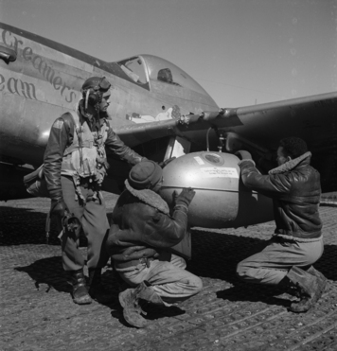
Confronting Segregation in the Military With the establishment of the draft in 1940, thousands of African Americans lined up to join the armed forces. By war's end, more than a million had served.They faced many hardships, beginning with their segregation in training camp. They ate in separate mess halls from the white troops and slept in separate barracks. Camps that had a single movie theater even made black trainees sit together in the last row.
In the early buildup to war, the marines and army air corps refused to take any African Americans.The navy limited African American duties to cooking, cleaning rooms, and shining shoes. One such “mess man” aboard the USS Philadelphia sent a letter to a newspaper hoping to discourage other black men from joining the navy. “All they would become,” he wrote, “is seagoing bellhops, chambermaids, and dishwashers.” The army accepted black GIs, but it excluded them from combat.The GIs served in segregated units led by white officers, often working in construction, supply, or other service groups.
Black leaders pressed the government to end military discrimination. In time, the armed services gave more black soldiers the opportunity to engage in combat and to become officers. The army air corps established its first black combat unit in 1941. Known as the Tuskegee Airmen, these pilots and their support crews showed that African Americans could handle the most demanding assignments. They served mainly as bomber escorts, engaging in direct combat with German fighter planes. The Tuskegee Airmen gained a reputation for skill and courage, shooting some 400 German attackers out of the sky. They were the only fighter group never to lose a bomber to enemy planes.

Seeking Opportunity and Equality on the Home Front Black leaders were also working to improve conditions at home. In June 1941, A. Philip Randolph, head of a powerful all-black railroad union, met with President Roosevelt at the White House. The government had done little to end discrimination in defense-related jobs. One steelmaker expressed the attitude of many in the defense industry when he said, “We have not had a Negro worker in twenty-five years, and do not plan to start now.” Roosevelt sympathized with black Americans, but the war in Europe had kept him from paying much attention to civil rights—until Randolph's visit.

Randolph focused Roosevelt's attention by threatening to lead a massive march on Washington to protest discrimination. He promised that unless Roosevelt acted, tens of thousands of African Americans would swarm into the nation's capital on July 1. The threat worked. On June 25, 1941, Roosevelt signed Executive Order 8802, outlawing discrimination by defense contractors.

This executive order helped pave the way for nearly a million African Americans to work for defense industries during the war. It also triggered a migration of African Americans out of the rural South and into the industrial cities of the North and the West. From 1940 to 1945, some 500,000 black Americans, attracted by higher-paying jobs, left the South. In the process, they escaped the Jim Crow laws that legalized segregation and kept many of them from voting. In the cities, however, black Americans faced other hardships, including a lack of housing and social services, as well as ongoing racial discrimination.

They also faced a white backlash. Race riots broke out in many cities across the country as black migrants competed with white residents for housing and jobs. One of the worst riots occurred in Detroit, Michigan, in the summer of 1943. A fistfight and other minor incidents ballooned into a widespread conflict. Mobs of rioters burned automobiles, looted stores, and engaged in bloody battles in the streets. The riots resulted in the deaths of 25 blacks and 9 whites.
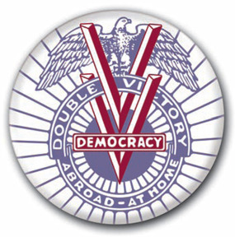
Challenging Racism at Home The Double V campaign's call for an end to racism and segregation received support from several African American organizations. One group, the National Urban League, had been helping black migrants since its founding in 1910. It opposed discrimination in defense plants, fought to integrate labor unions, and pushed federal officials to ensure equal opportunity for African Americans in housing and employment. Another group, the NAACP, had been fighting for equality since 1909. It focused on seeking racial justice through the courts. During the war, its membership soared.
The National Urban League and the NAACP did not want to undermine the war effort, so they avoided making strident demands. Another organization, the Congress of Racial Equality (CORE), took a tougher stance.Founded in 1942, CORE believed in confronting discrimination through nonviolent protest. Its efforts, along with the work of the NAACP and the National Urban League, helped set the stage for the postwar civil rights movement.

6. Jewish Americans and the War
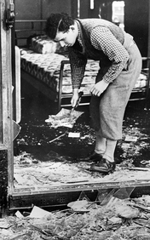
The war brought special hardships for Jewish Americans. They not only made sacrifices like other Americans did, but they also suffered from knowing that millions of Jews were being imprisoned and murdered in Europe. Furthermore, they could do nothing to stop the slaughter.
Growing Alarm at Nazi Persecution of Jews American Jews started hearing reports of Nazi persecution in Germany shortly after Hitler took power in 1933. That year, the Nazi Party organized a nationwide boycott of Jewish businesses. Two years later, the German parliament stripped Jews of their citizenship. It also forced them to sell their property to non-Jews. Shortly after taking over Austria in March 1938, Hitler began persecuting Austrian Jews. Tens of thousands fled.
Then, on November 9, 1938, the Nazis instigated a night of anti-Jewish rioting known as Kristallnacht, or the “night of broken glass.” Mobs smashed the windows of thousands of Jewish-owned shops, burned nearly every Jewish synagogue in Germany, and killed more than 90 Jews. Some 30,000 Jewish men were arrested and sent to concentration camps. These events received detailed coverage in the American press.
After Kristallnacht, thousands of Jews wanted to flee to the United States. But the 1924 National Origins Act placed severe limits on the number of immigrants from any one nation. Besides, very few Americans wanted to open the country to a flood of immigrants, especially during the Depression.

These factors, combined with widespread anti-Semitism, led to incidents such as the voyage of the steamship St. Louis. In 1939, the St. Louis carried 930 Jews from Germany across the Atlantic Ocean to Cuba. But Cuba refused to accept the refugees. The St. Louis next steamed north along the Florida coast. Roosevelt ignored pleas for help from the ship's passengers, however. With food and water running low, the captain decided to return to Europe. A number of passengers ended up in France and the Low Countries or back in Germany. Many would later die in concentration camps.
During the war, reports trickled out of Europe about mass killings of Jews by the Nazis. Accounts from Poland told of concentration camps that had gas chambers for killing Jews. Few American news sources passed this information along to the public, however. When they did, the stories did not make headlines. Editors failed to tie these stories together or explain that they represented a Nazi campaign to exterminate European Jews.
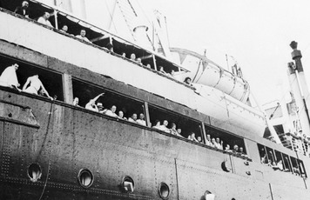
Jewish Americans Urge the Government to Help Jews in Europe Jewish Americans, however, were painfully aware of the mass murder of European Jews. Many had relatives and friends in Europe but felt helpless to save them. Others took action, such as boycotting German products, raising money for refugees, and holding public demonstrations. In July 1942, about 20,000 people gathered at Madison Square Garden in New York City to protest Nazi brutality. Similar rallies took place in Chicago, Los Angeles, and other cities. Jews urged officials to send food packages to concentration camps and to set up prisoner exchanges to free Jews. Jewish groups pleaded with legislators and the president to change immigration laws.
Several factors kept the government from offering refuge to victims of the Nazis. Polls showed that most Americans, their views colored by anti-Semitism, were unwilling to admit large numbers of European Jews. Even many American Jews worried that massive immigration might intensify anti-Semitic feelings. Roosevelt also feared espionage and sabotage. Advisors insisted that any stream of Jewish refugees into the United States would include Nazi agents.
By the end of 1942, the government knew that Hitler was slaughtering Jews in a systematic way. Still, it was not until 1944 that Roosevelt issued an executive order creating the War Refugee Board. This agency arranged for Jewish refugees to stay at centers in Italy and North Africa, as well as in former army camps in the United States. Henry Morgenthau Jr., the only Jew in Roosevelt's cabinet, later recalled the mission of the War Refugee Board. “The stake was the Jewish population of Nazi-controlled Europe,” he said. “The threat was their total obliteration. The hope was to get a few of them out.”

Jewish American GIs Go to War Like other Americans, Jews did what they could to support the war effort. More than 500,000 Jewish Americans went to war, including half of all Jewish men aged 18 to 44.
The opportunity to serve in the armed forces transformed the lives of many Jewish American soldiers. Many had previously been unaware of life outside their urban neighborhoods. As GIs, they often trained in the rural South and then journeyed overseas. Both experiences opened their eyes to unfamiliar cultures.
In the armed forces, Jewish American GIs often felt the sting of prejudice. A frustrated corporal, after two years in the marines, sent a letter to the editor of a Jewish magazine. “I am the only Jewish boy in this detachment,” he wrote. “I am confronted with anti-Semitism on all sides.”
Other Jewish soldiers had a different experience, however, that affirmed their faith in their country and its ideals. In 1944, GI and future novelist Leon Uris wrote a letter to his father noting that he “fought beside Catholics, Protestants, and Mormons, Indians, Irish, Italians, Poles.” Uris's experience convinced him that “it's not the religion we look at, but the man himself.”

7. Mexican Americans Leave the Fields for War Work
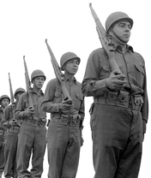
During the war, many Mexican Americans faced discrimination in their daily lives. Like African Americans, some wondered whether joining the armed forces made sense. “Why fight for America,” one soldier asked, “when you have not been treated as an American?” Despite such doubts, many Mexican Americans enlisted in the armed forces, while others left their traditional farm jobs or segregated urban neighborhoods to join the industrial workforce. These changes opened up new opportunities for Mexican Americans.
Mexican Americans and Mexicans Join the War Effort About half a million Mexican Americans served in the armed forces during World War II. One of their slogans was “Americans All.” As this suggests, many saw the war as an opportunity to prove their loyalty and become part of the mainstream.
A higher proportion of Mexican Americans fought in combat units than any other ethnic group. In addition, Mexican American soldiers suffered heavy casualties in comparison with other ethnic groups. They also received many combat awards. Fourteen Texans received the Congressional Medal of Honor for heroism in the war. Of those, five were Mexican Americans. One Mexican American leader summed up the social effects of the war this way:
“This war . . . has shown those ‘across the tracks' that we all share the same problems. It has shown them what the Mexican American will do, what responsibility he will take, and what leadership qualities he will demonstrate. After this struggle, the status of the Mexican Americans will be different.”
—Manuel de la Raza, quoted in Carlos Muñoz Jr., Youth, Identity, Power: The Chicano Movement, 1989

Before the war, discrimination had barred most Mexican Americans from many high-paying industrial jobs. The war, with its labor shortages, changed that. Thousands of Mexican Americans left their rural, agricultural lives behind and migrated to industrial centers to work in the defense industry.
To replace Mexican American farm labor, the government looked south of the border. In August 1942, the United States and Mexico devised the Bracero Program. Bracero is the Spanish term for “manual laborer.” Under the program, Mexican citizens received short-term contracts to come to the United States to work. By 1944, about 120,000 Mexican braceros were performing farm labor in 21 states.Other Mexicans did maintenance work on railroads in the West.

Prejudice Against Mexican Americans Erupts in Zoot Suit Riots Mexican Americans in major cities lived apart from whites. Their barrios, or neighborhoods, were nearly self-sufficient, with their own shops, churches, and schools. Like many immigrant communities, barrios tended to develop in poor, run-down parts of cities, where crime rates were often high. The barrio of East Los Angeles during the war was no different. Mexican Americans there had little regular contact with white Americans. Relations between the two groups were hostile. In 1943, a full-scale riot erupted in the barrio. Part of the focus of the riot was a fashion fad known as the “zoot suit.”
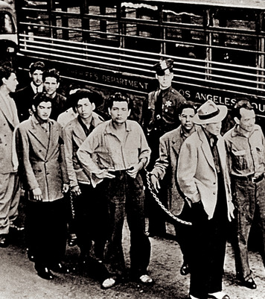
A zoot suit consists of a flat, broad-brimmed felt hat, a long suit coat with large shoulder pads, and baggy pants that flared at the knee. Many Mexican American teenagers, or pachucos, in East Los Angeles began dressing in this flashy style and wearing their hair long in the back, in the ducktail fashion. White Americans tended to associate the zoot suit with Mexican American street gangs, many of whom also adopted the style. Thus, many people saw the outlandish zoot suit as a symbol of lawlessness.

Pachucos and servicemen from the local navy base occasionally clashed. Those small-scale clashes escalated in June 1943 into the Zoot Suit Riots. For several nights, mobs of sailors and marines roamed the streets of the barrio, attacking not just gang members but also anyone wearing a zoot suit. They beat hundreds of pachucos and ripped off their suits.
The Los Angeles police did little to stop the servicemen. Instead, they arrested the victims and hauled them off to jail. Meanwhile, newspapers whipped up the mobs with headlines such as “Zoot Suiters Learn Lesson in Fights with Servicemen.” Military police finally stepped in to end the violence. Later, an investigating committee found that the main causes of the Zoot Suit Riots were racial prejudice, police discrimination, and inflammatory articles in the press.

8. Preparing for War in the Pacific
World War II took a very different course in Asia and the Pacific. After the shock of the Pearl Harbor attack, American forces in the Pacific needed several months to regroup. During this time, Japan took control of much of the region's natural resources, including oil and rubber. Through conquest, Japan formed what it called the Greater East Asia Co-Prosperity Sphere. The “Co-Prosperity” in the title had nothing to do with sharing the wealth. Instead, Japan's goal was its own economic self-sufficiency, along with expanded political influence.
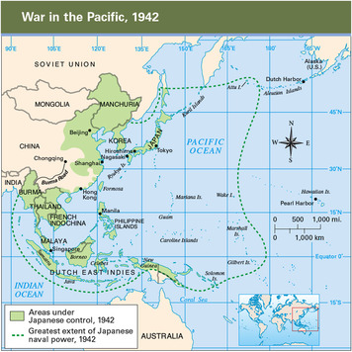
The Japanese Advance in Asia and the Pacific Japan's attack on Pearl Harbor was just the first in a series of strikes against Allied territory in the Pacific. By the end of March 1942, the Japanese had captured British Hong Kong and Singapore, the American islands of Guam and Wake, and the oil-rich Dutch East Indies. Japan had also invaded several larger possessions of the Allies, including the American-held Philippine Islands and the British colony of Burma.
In the Philippines, Americans and Filipinos under General Douglas MacArthur resisted a fierce Japanese onslaught. Disease and malnutrition killed many of the defenders. In March, Roosevelt ordered MacArthur to leave the islands. Upon his departure, the general promised, “I shall return.” Two months later, Japan completed its conquest of the Philippines. On the largest island, the Japanese rounded up 70,000 starving, exhausted American and Filipino prisoners and marched them up the Bataan Peninsula near Manila to a prison camp. During the brutal 63-mile march, Japanese soldiers beat and bayoneted many of the prisoners. More than 7,000 died on the infamous Bataan Death March.
The fall of the British colony of Burma, in May 1942, had serious consequences for China. Japan already controlled most of coastal China, including the main ports. No supplies could reach the Chinese army by sea. China relied on British and American supplies carried in from India over the Burma Road. Now Japan had cut this lifeline. If Japan defeated China, hundreds of thousands of Japanese soldiers would be free to fight elsewhere. To help China keep fighting, the Allies set up an airborne supply route over the Himalayas.

The Pacific War Begins in the Air and at Sea Japan's string of victories in the Pacific hurt American confidence. To boost morale, Roosevelt urged his military chiefs to strike directly at the Japanese home islands. They came up with a plan to fly B-25 bombers off an aircraft carrier. The B-25 could make a short takeoff and also had the range to presumably reach Japan and then land at Allied airfields in China.

On April 18, 1942, 16 bombers took off from the carrier Hornet, which had sailed to within 650 miles of Japan. Led by pilot Lieutenant Colonel James Doolittle, the bombers hit Tokyo and other Japanese cities. Although the bombs did little damage, this surprise attack thrilled Americans as much as it shocked the Japanese. Japan reacted by putting more precious resources into defending the home islands. It also decided to try to destroy the remaining American fleet, a plan that would prove disastrous.
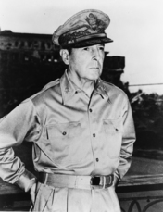
During Doolittle's raid, American code breakers got news of enemy activity far to the south in the Coral Sea. Japan was moving into position to isolate Australia, a key American ally. To stop the Japanese, Admiral Chester Nimitz sent two aircraft carriers, several cruisers, and a few destroyers—all he could spare at the time. They would face a larger Japanese force that included three carriers.
The resulting Battle of the Coral Sea, in early May 1942, was fought entirely by carrier-based aircraft. It was the first naval battle in history in which the enemies' warships never came within sight of each other. Japanese aircraft sank the carrier Lexington and damaged the Yorktown. American planes sank one Japanese carrier and damaged the other two. Despite fairly even losses, the Americans gained a strategic victory. They blocked Japanese expansion to the south, and they learned a valuable lesson—the Japanese navy could be beaten.

Military Leaders Consider Their Options in the Pacific The “Europe First” strategy put Pacific commanders at a disadvantage. Because they had fewer ships, planes, and soldiers than the Japanese, a defensive strategy made sense. American naval forces would try to contain the Japanese, stopping their expansion in the Central and South Pacific. Critics in the navy pointed out that this strategy allowed the Japanese to strengthen their hold on newly won territories, making those lands harder to win back later. As part of the defensive strategy, these critics advised keeping the Japanese off balance with occasional attacks.
Some navy officials wanted to go on the offensive, and they debated different strategies. One idea was to build air bases in the Aleutian Islands, the part of Alaska that extends westward toward Japan. But pilots and their crews would have had to deal with the snow, wind, and fog that afflicted this region. Also, all supplies would have had to be shipped in from the U.S. mainland.

Another idea was to build bases in China. China's coast would have made an ideal staging area for an air assault on nearby Japan. However, the fuel, bombs, and parts needed to keep bombers in the air could best be delivered by sea, and the Japanese controlled China's ports. Inland air bases might have worked, but they would have had to be supplied by planes flying over the Himalayas from India.
A third offensive option called for liberating Japanese-held territory in the Pacific. By first freeing islands far from Japan, American forces could gradually move closer to get within B-29 striking distance. This would take time, though, and Japanese resistance would stiffen the closer the Americans got to Japan. Many of the islands were well fortified, so American casualties would be high.

9. War in the Pacific, 1942-1945
The Americans led the Allied forces in the Pacific and did most of the fighting. When they went on the offensive, they chose a strategy of liberating Japanese-held islands in the Pacific and using them as stepping-stones. Each captured island served as a base for assaults on other islands as the Allied forces moved closer to Japan.
One of the keys to Allied success in the Pacific was the use of secret codes. The United States trained a special group of Navajo Indian “code talkers” for this task.Because Navajo is not a written language and is understood by very few people, it made an excellent basis for a code to transmit vital information. The Navajo code talkers played a key role in the Pacific campaign.
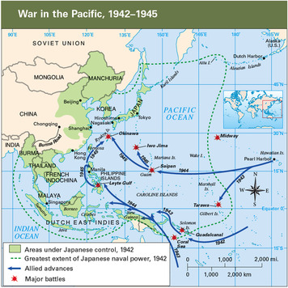
The Japanese Offensive Ends at the Battle of Midway Before the Allies could go on the offensive, they had to stop Japanese expansion. They achieved this goal at the Battle of Midway, in June 1942. The Americans intercepted a Japanese message telling of plans for a major offensive. They figured out that the target was the U.S. base at Midway, a pair of islands about 1,200 miles northwest of Pearl Harbor. With this knowledge, the navy sat in wait for the Japanese fleet.
At Midway, Japanese naval strategists hoped to destroy the U.S. Pacific Fleet, which had been their plan since Doolittle's raid on Tokyo. Instead, the U.S. Navy won a resounding victory. American planes from Midway and from three aircraft carriers demolished the enemy force, destroying all four Japanese carriers, a cruiser, and about 300 aircraft. Japan never recovered from the loss of the carriers and so many experienced pilots. The Battle of Midway was Japan's last offensive action.From then on, Japan would focus on defense.

Liberating the Pacific Islands Proves Costly A strategy known as leapfrogging enabled the Americans to go on the offensive with limited resources. They would often leapfrog, or bypass, a heavily defended island and then capture a nearby island that was not well defended. The captured island was then used as an airbase to bomb the Japanese-held island and prevent ships from resupplying it. Cut off from reinforcements and supplies, the Japanese forces would be left to wither.General MacArthur described this leapfrogging approach as “hit 'em where they ain't—let 'em die on the vine.”

Despite the success of leapfrogging, many of the island invasions came at a terrible cost. Thousands of soldiers died in the jungles of Guadalcanal, New Guinea, Tarawa, and Saipan. But they kept pushing the Japanese back, closer and closer to the home islands. In October 1944, MacArthur made his triumphant return to the Philippines, where his forces would battle the Japanese until the end of the war. In August 1944, the marines finished retaking the Mariana Islands. The Marianas campaign was a landmark victory. It gave the Allied Pacific force secure bases from which long-range B-29s could make strategic bombing raids on Japan.
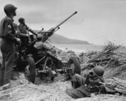
The Final Push Toward Japan Brings Heavy Losses The Allied push through the Pacific steadily shrank the defensive perimeter that Japan had established around the home islands. That perimeter would all but disappear if the Allies could capture the key islands of Iwo Jima and Okinawa. Iwo Jima's airfields would offer a place for B-29s to land in an emergency. They would also serve as a base for fighter planes escorting bombers over Japan. Control of Okinawa, just 310 miles south of Japan, would give Americans a prime staging area for the invasion of Japan. To meet these threats, Japanese military leaders moved their best army units from Japan and China to defend the two strategic islands.

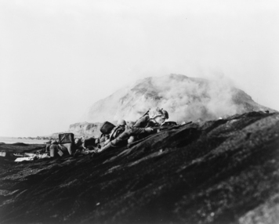
On the small volcanic island of Iwo Jima, the defenders dug caves, tunnels, and concrete-lined bunkers. Three months of Allied bombardment before the February 1945 invasion did little to soften the defense. The month-long Battle of Iwo Jima was among the bloodiest of the war. Nearly all of the 22,000 Japanese troops followed their commander's orders to fight to the death. To win the island, more than 6,800 American troops died. Admiral Nimitz noted that on Iwo Jima, “uncommon valor was a common virtue.”
To take the much larger island of Okinawa, the Allies mounted a huge amphibious, or sea-to-land, invasion in April 1945. More than 1,200 American and British ships, including 40 aircraft carriers, supported a combined army-marine force of 182,000. As on Iwo Jima, the 120,000 troops defending Okinawa strongly resisted the American invaders. The bloody combat at the Battle of Okinawa, much of it hand-to-hand, continued for two months. It claimed the lives of some 12,000 American soldiers and more than 100,000 Japanese soldiers.
Meanwhile, another kind of combat was taking place in the surrounding waters. Earlier in the Pacific war, the Japanese had introduced a new weapon—kamikaze pilots. Hundreds of men flew their bomb-filled planes directly into the vessels of the Allied fleet. Kamikaze attacks sank or damaged hundreds of ships. But they failed to sink any aircraft carriers, which were their main targets.

The Manhattan Project Develops a Top Secret Weapon The stage was now set for an invasion of Japan. But the United States had its scientists working on another option. In 1939, German American scientist Albert Einstein had written to President Roosevelt explaining that scientists might soon be able to turn uranium into a new form of energy. That energy, he said, could be harnessed to build “extremely powerful bombs.” Einstein expressed his fear that Germany was already engaged in experiments to create such an atomic bomb. The power of this explosive weapon comes from the energy suddenly released by splitting the nuclei of uranium or plutonium atoms.

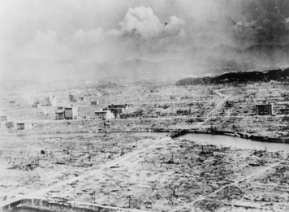
Three years after Einstein sent his letter, the government established the Manhattan Project, a top-secret program to develop an atomic weapon. A team of scientists, many of whom had fled fascist nations in Europe, carried on the research and development. Much of the work took place at a lab in Los Alamos, New Mexico. By the summer of 1945, their efforts had produced the first atomic bomb.On July 16, that test bomb was exploded on a remote air base in the New Mexico desert. Physicist J. Robert Oppenheimer witnessed the blinding flash of light, intense heat, and violent shock wave that the bomb produced. He later said the blast reminded him of a line from Hindu scripture: “I am become Death, the destroyer of worlds.”
Truman Faces a Decision to Drop the Bomb After the successful test of the atomic bomb, or A-bomb, President Truman had to decide whether to drop the bomb on Japan or to launch an invasion.After Iwo Jima and Okinawa, Truman knew an invasion would produce enormous casualties. The number of Allies killed and wounded might reach half a million, he was told.
Truman faced a stubborn enemy. American B-29s were already destroying Japan with conventional bombs, including incendiaries. These firebombs killed hundreds of thousands of people and turned large areas of major Japanese cities, with their masses of wooden buildings, into cinders. At the same time, a naval blockade cut off the supply of raw materials to Japan. The bombing and blockade had left many Japanese starving, and many of the country's leaders realized that Japan could not possibly win the war. Yet the Japanese refused to accept the unconditional surrender Truman demanded. In fact, they seemed ready to fight to the last man, woman, and child, in the spirit of the kamikaze. Oppenheimer and others believed only the shock of an atomic bomb would end the Japanese resistance.
Some officials objected to dropping the A-bomb. General Curtis LeMay insisted that his B-29 bombing campaign would soon bring Japan's surrender. General Eisenhower agreed. “It was my belief,” Eisenhower wrote later, “that Japan was, at that very moment, seeking some way to surrender with a minimum loss of ‘face' [honor].” Others maintained that the Japanese would give up if Truman would agree to let them keep their beloved emperor.
The United States Bombs Hiroshima and Nagasaki Truman stuck to his demand for an unconditional surrender. He told Japan that the alternative was “prompt and utter destruction.” On August 6, 1945, a B-29 named the Enola Gay dropped an atomic bomb on Hiroshima, Japan, a city of 300,000 people. Within seconds of the explosion, up to 80,000 people died. The blast's shock wave toppled nearly 60,000 structures, and hundreds of fires consumed the rest of the city. Three days later, the United States dropped a second atomic bomb. This one obliterated the city of Nagasaki, killing some 40,000 people instantly. As many as 250,000 Japanese may have died from the two atomic bombs, either directly or as the result of burns, radiation poisoning, or cancer.
Truman had no regrets. “Let there be no mistake about it,” he said later. “I regarded the bomb as a military weapon and never had any doubt that it should be used.” The destruction of Nagasaki brought a Japanese surrender. Truman received this informal surrender on August 14, Victory over Japan Day, or V-J Day. The terms of the surrender allowed the emperor to keep his office but only in a ceremonial role. The Allies officially accepted the surrender aboard the American battleship Missouriin Tokyo Bay.
Millions celebrated V-J Day, which marked the end of the Second World War. But they also mourned the loss of lives. About 55 million died—30 million of them civilians. The Soviet Union paid the highest human cost, with more than 20 million of its people killed. Some 400,000 Americans, nearly all in the military, gave their lives. Most Americans believed strongly that those soldiers, sailors, airmen, and others had died for a noble cause.

Summary

World War II lasted from 1939 to 1945. The United States played a major role in both main fronts of the war—Europe and the Pacific. To retake Europe, the Allies invaded North Africa, Italy, and France, and then moved on to Germany. To retake the Pacific, they fought island by island, until they closed in on Japan.

Allies versus Axis powers The Allies' strategy of “Europe First” set the United States, Britain, and the USSR against the Axis countries of Germany and Italy. In the Pacific, the United States and China battled Japan.

Battle of Stalingrad Hitler's effort to conquer the USSR ended at Stalingrad, where the Red Army forced the Nazis to retreat. The Soviets then pushed westward to Germany.

D-Day The Allies invaded France on June 6, 1944. Then they swept into Germany and took Berlin. Hitler committed suicide, and Germany surrendered.

Holocaust Moving through Poland and Germany, Allied forces liberated Jews and others from Nazi concentration camps and began to uncover the horrors of the Holocaust.

Battle of Midway The United States stopped Japanese expansion in the Pacific at the Battle of Midway. It then went on the offensive, using tactics like leapfrogging to overcome Japanese resistance.

Battle of Okinawa After the Battle of Okinawa, the Allies were poised for an invasion of Japan. Given the losses at Okinawa, however, they knew it would be a long and costly struggle.

Manhattan Project Scientists with the Manhattan Project developed an atomic bomb and tested it in July 1945. A month later, the United States dropped two bombs on Japanese cities, forcing Japan's surrender and bringing an end to World War II.

