Further Symbolism of Wizard of Oz

Symbolism in Wizard of Oz
As we watch parts of the Wizard of Oz, think about the historical themes and events we’ve been discussing. Develop your own theory about symbolism in the film! First of all, brainstorm some of the key characters and events in the Wizard of Oz. Then, as we watch the film, what do you think they represent? Explain your thinking!
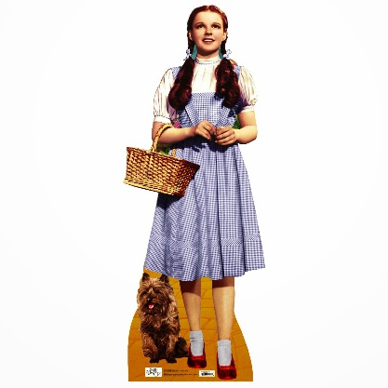
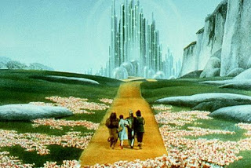

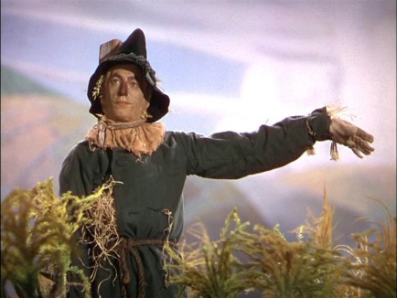
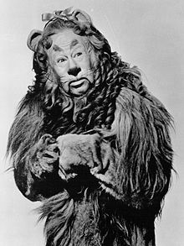
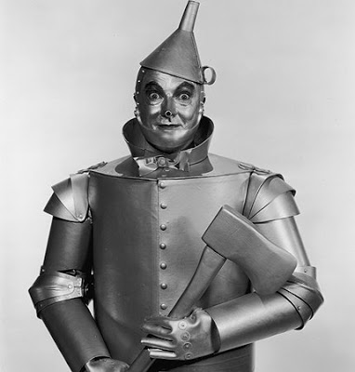
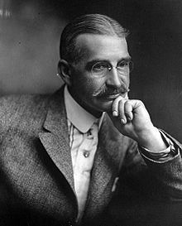
Lyman Frank Baum was born May 15, 1856 and died on May 6, 1919 (age 62) in Hollywood. In 1888, Baum and his wife moved to Aberdeen, Dakota Territory and opened a store. It eventually went bankrupt and he turned to writing. He was ‘out West’ when Sitting Bull was killed and when Wounded Knee happened. He also experienced the rapid changes happening in the West between 1888 and 1890. Many historians think the Wizard of Oz is political allegory for the events happening at the time. He even sang in a quartet with a man James Kyle, who became one of the first Populist Senators in U.S. history. He moved back to Chicago by 1897.

