James Madison  Mar 4, 1809-  Mar 4, 1817 | 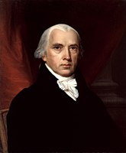4
James Monroe  Mar 4, 1817-  Mar 4, 1825 | 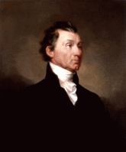5
John Q Adams  Mar 4, 1825  March 4, 1829 | 6
Andrew Jackson  Mar 4, 1829-  Mar 4, 1837 | 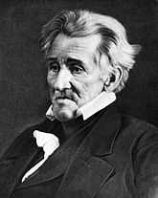7
Martin Van Buren  Mar 4, 1837-  Mar 4, 1841 | 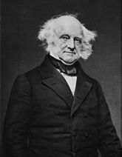8
William Henry  Harrison  Mar 4, 1841-  April 4, 1841 | 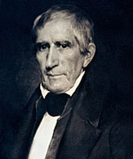9
John Tyler  April 4, 1841-  Mar 4, 1845 | 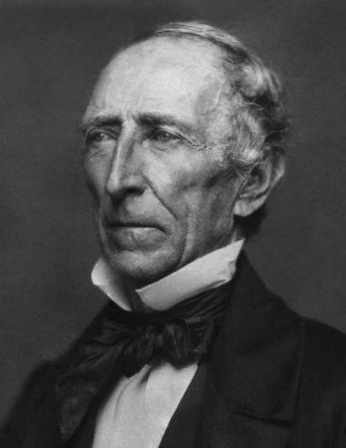10
James Polk  Mar 4, 1845  Mar 4, 1849 | 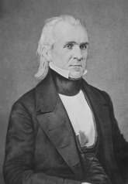11

