North Korea Tests Another Missile, Days Before New Negotiations With U.S. Begin
Tuesday’s launch was the country’s ninth round of weapons tests since late July.
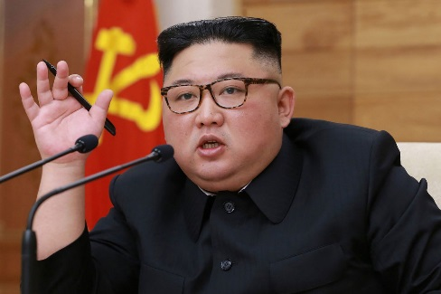
SEOUL, South Korea (AP) — North Korea fired a ballistic missile from the sea on Wednesday, South Korea’s military said, a suggestion that it may have tested an underwater-launched missile for the first time in three years ahead of a resumption of nuclear talks with the United States this weekend.
The North Korea missile flew about 450 kilometers (280 miles) at a maximum altitude of 910 kilometers (565 miles) after liftoff from an unspecified place in the waters off the North’s eastern coastal town of Wonsan, Seoul’s Joint Chiefs of Staff said in a statement. South Korean and U.S. intelligence authorities were analyzing more details of the launch, it said.
Japan lodged an immediate protest against North Korea, saying the missile landed inside Japan’s economic exclusive zone. If confirmed, it would be the first North Korean missile that has landed that close to Japan since November 2017.
South Korean military officials wouldn’t officially disclose whether the missile was fired from a submarine, a barge or another possible platform. But during an emergency National Security Council meeting, council members placed weight on the possibility that North Korea performed a submarine-launched missile test and expressed “strong concerns” over the North Korean move, according to South Korea’s presidential office.
North Korea having the ability to launch missiles from submarines would be alarming because such weapons are harder to detect in advance. Some experts say the North is attempting to raise the stakes and ramp up pressure on the United States before their nuclear negotiators meet on Saturday.
“The North is trying to convey a message that time is not on the side of the United States and that it could take a different path if the working-level talks don’t go the way it wanted,” said Du Hyeogn Cha, a visiting scholar at Seoul’s Asan Institute for Policy Studies.
The big message to the US: we are not unilaterally disarming so don’t even think about using any of your “d” words this weekend when we start talking again.
Folks, this was not a short range ballistic missile. We have a potentially brand new bad boy (SLBM) on the proverbial docks right before working level talks are supposed to recommence.
The Joint Chiefs of Staff statement said the weapon fired Tuesday is believed to be a “Pukguksong-class” missile. It refers to a solid-fuel missile that North Korea tested-launched from an underwater test platform in 2016, with the hope that it could eventually be a part of its submarine weaponry. That missile flew 500 kilometers (310 miles), and North Korean leader Kim Jong Un said at the time that his country had gained “perfect nuclear-attack capability.”
North Korea has been trying to obtain the ability to fire ballistic missiles from submarines, though the tests needed for that appear to have been put off while it has been engaged in nuclear diplomacy with the United States since early last year.
When the North’s news agency in July publicized photos of a newly built submarine and said its operational deployment “is near at hand,” some outside experts said it was North Korea’s biggest submarine with several launch tubes for missiles. An estimated 70 other submarines possessed by North Korea only have launch tubes for torpedoes, not missiles, according to the experts.
Cha said flight data provided by South Korea’s Joint Chiefs of Staff suggested that it was more likely that the North tested the same type of missile it fired in 2016, instead of a new weapons system.
Japan also confirmed the North Korean missile launch. It earlier said North Korea fired two missiles but later corrected itself and said there had been a single launch and perhaps the missile broke into two parts.
Japanese Defense Minister Taro Kono said the missile fell inside Japan’s exclusive economic zone. He called the launch “a serious threat to Japanese national security.” Kono also said the launch without an advance warning was an “extremely problematic and dangerous act” for the safety of vessels and aircraft.
Kono declined to say whether it was a submarine-launched missile.
Japanese Prime Minister Shinzo Abe condemned the launch and said it violated U.N. resolutions that ban North Korea from conducting any launch using ballistic technology.
“We will continue to cooperate with the U.S. and the international community and do the utmost to maintain and protect the safety of the people as we stay on alert,” Abe said.
The launch may also be seen as a way for North Korea to express its displeasure over South Korea displaying for the first time some of its newly purchased U.S.-made F-35 stealth fighter jets at its Armed Forces Day ceremony on Tuesday. The North has called the F-35 purchases a grave provocation that violate recent inter-Korean agreements aimed at lowering military tensions.
Cha stressed the North Korean launch demonstrated its expanding ability to strike allies South Korea and Japan, not the U.S. mainland.
North Korea has been maintaining its self-imposed moratorium on nuclear and long-range missile tests since Kim began diplomacy with U.S. President Donald Trump.
But since his second summit with Trump in Vietnam in February collapsed without reaching any agreement, Kim has hinted at scrapping that weapons test moratorium and demanded Trump to come up with mutually acceptable new proposals by December. In Hanoi, Trump rejected Kim’s calls for broad sanctions relief in exchange for partially surrendering its nuclear capabilities.
Tuesday’s launch, which was the North’s ninth round of weapons tests since late July, came hours after Choe Son Hui, North Korea’s first vice minister of foreign affairs, said North Korea and the United States have agreed to resume working-level nuclear negotiations on Saturday following a preliminary contact on Friday.
U.S. State Department spokeswoman Morgan Ortagus, who is traveling with Secretary of State Mike Pompeo in Rome, confirmed that U.S. and North Korean officials plan to meet within the next week.
Both North Korea and the United States didn’t say where the weekend meetings would take place.

Over 100 Dead and Thousands Wounded in Iraq as Unrest Continues
BY QASSIM ABDUL-ZAHRA / AP OCTOBER 6, 2019
(BAGHDAD) — Seven anti-government demonstrators were killed Sunday in ongoing protests in the capital Baghdad, the latest fatalities in six days of clashes that have left more than 100 dead and thousands wounded.
Iraq’s government has scrambled to contain the popular anger that has racked Baghdad and a number of southern cities since Tuesday. Security forces responded with a crackdown on the spontaneous rallies of demonstrators demanding jobs, better services and an end to endemic corruption in the oil-rich country. In the first official statement from the government accounting for the violence, Interior Ministry spokesman Saad Maan said Sunday that 104 people had been killed in the six days of unrest, including eight members of the security forces, and more than 6,000 wounded. He said an investigation was under way to determine who was behind the most deadly day of violence, in Baghdad on Friday.
The unrest is the most serious challenge facing Iraq two years after the victory against Islamic State militants. The chaos also comes at a critical time for the government, which has been caught in the middle of increasing U.S.-Iran tensions in the region. Iraq is allied with both countries and hosts thousands of U.S. troops, as well as powerful paramilitary forces allied with Iran.
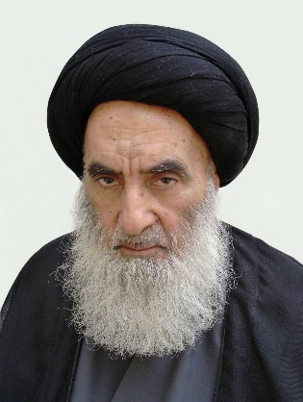
Iraq’s most senior Shiite spiritual leader, Grand Ayatollah Ali al-Sistani, has urged the protesters and the security forces to end the violence while the country’s prime minister has called on the protesters to go home. Prime Minister Adel Abdul-Mahdi also pledged to meet with the protesters wherever they are and without any armed forces, to hear their demands.
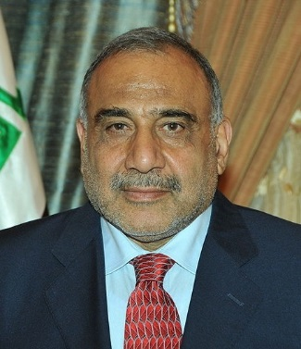
Abdul-Mahdi defended the security forces, saying they were carrying out their duties and would only use force in extreme cases of self-defense. “We can’t accept the continuation of the situation like this,” Abdul-Mahdi told his Cabinet late Saturday in televised remarks. “We hear of snipers, firebombs, burning a policeman, a citizen.”
Speaking on Sunday, Maan, the Interior Ministry spokesman, said protesters have burned 51 public buildings and eight political party headquarters. He claimed security forces didn’t confront the protesters, adding that “malicious hands” were behind targeting protesters and security members alike.
That contradicted accounts from demonstrators and journalists at the scene who have said they witnessed security forces firing on demonstrators. Some protesters said snipers also took part in breaking up the protests. Maan said most of those killed Friday were hit in the head and heart. Officials had said earlier there were attempts at “sedition” from snipers who targeted security and protesters alike. They didn’t elaborate. Late Saturday, the prime minister announced a number of measures designed to appease the protesters, including paying out unemployment benefits and providing subsidized housing and land for low-income groups.
Still, demonstrators took to the streets again Sunday— although in smaller numbers. Hundreds gathered on side streets near Sadr City, a Baghdad suburb, some four kilometers (2.5 miles) from Tahrir Square, which has been the destination of the weeklong rallies, although authorities have prevented protesters from reaching it.
A medical official in a local hospital and a security official said seven protesters were killed and 17 others wounded as they tried to break through a security cordon to head to the city center. The officials, who did not provide details, spoke on condition of anonymity because they were not authorized to speak to reporters. Security forces have beefed up their presence in central Baghdad, deploying as far as Sadr City to seal off Tahrir Square.
Army troops blocked a main road Sunday to prevent the protesters from advancing. Soldiers then fired toward the protesters to push them back. After about an hour, there was more intense gunfire, with soldiers firing over the heads of protesters as they tried to advance. Ducking in reaction to the fire, some protesters piled over one another trying to hide behind the wall of a nearby water fountain. One protester carrying a drum chanted “peaceful, peaceful,” as others joined in. As the gunfire continued, protesters set tires on fire. Some demonstrators arrived in rickshaws, which have been used to carry the wounded from the bloody clashes.
The U.N. envoy for Iraq appealed for an end to the violence and called for holding to account those responsible. “This must stop. I call on all parties to pause and reflect,” Jeanine Hennis-Plasschaert tweeted Saturday night. Meanwhile, Abdul-Mahdi pledged to meet with the demonstrators to hear their demands. “I am ready to go wherever our brotherly protesters are and meet them or send them envoys to other locations without any armed forces,” he said late Saturday. “I will go and meet them without weapons and sit with them for hours to listen to their demands.”
He also decreed that those killed in the protests, whether demonstrators or security forces, would be considered “martyrs” eligible for state benefits. Earlier on Sunday, Baghdad’s streets had been mostly quiet and traffic thin as an eerie calm prevailed. Students made it to schools and government employees returned to work. But burnt tires and debris littered thoroughfares while security remained heavily deployed in many neighborhoods.
Atheer Assem, a pizza restaurant owner, said he was able to shop Sunday, the start of the working week, for ingredients for his baked goods. But he said his clients have stopped coming to his shop because of the violence, even though it is in a neighborhood that has not witnessed any protests.
“The protests are making people afraid to go out,” he said, estimating his sales to have dropped by 70 percent.

