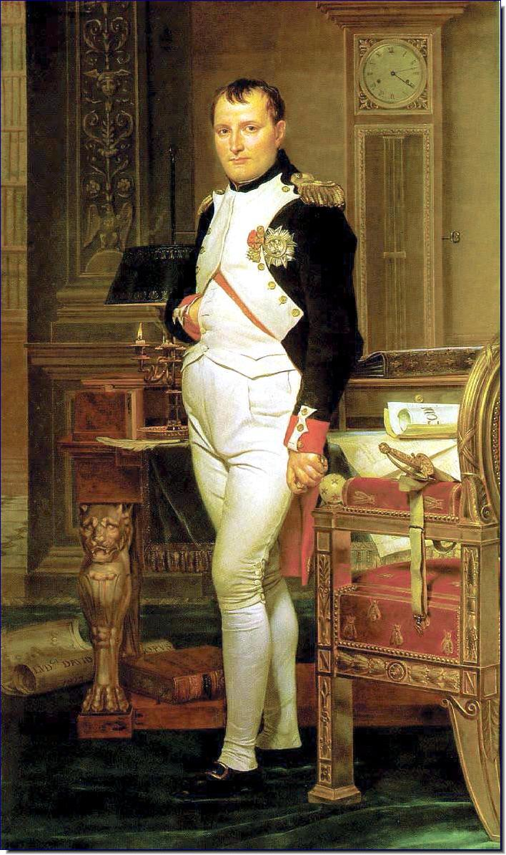

Personal life:

My biggest mistakes:

At the end of my life…

I am significant to history in that…

Interesting Facts…

What did I do?

Who am I?