Lebensborn Program

What is the Lebensborn program? What was the program supposed to do? (5)
__________________________________________________________________________________________________________________________________________________________________________________________________________________________________________________________________________________________________________________________________________________________________________________________________________________________________________________________________________________________________________________________________________________________________________________________________________________________________________________________________________________________________________________________________________________________________________________________________________________________________________________________________________________
How did the attitude toward the people in the program change over time? What caused the change in attitude? (5)
__________________________________________________________________________________________________________________________________________________________________________________________________________________________________________________________________________________________________________________________________________________________________________________________________________________________________________________________________________________________________________________________________________________________________________________________________________________________________________________________________________________________________________________________________________________________________________________________________________________________________________________________________________________
What is Lebensbraum? ___________________________________________________
________________________________________________________________________________________________________________________________________________________________________________________________________________________________________________________________________________________
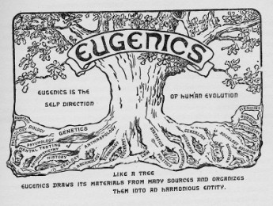
eu·gen·ics yo͞oˈjeniks/
The science of improving a human population by controlled breeding to increase the occurrence of desirable heritable characteristics. Developed largely by Francis Galton as a method of improving the human race, it fell into disfavor only after the perversion of its doctrines by the Nazis.

As you are listening to this short piece on Eugenics, fill in the blanks.

“The 1930’s - _____________ were the hay day of the _____________ movement in the United States. The goal- to rid the country of the __________________________ , ________________________ .”

“_______________________ men and women, boys and girls, __________________.”

“_______ states had Eugenics programs, but ___________ was in a league of it’s own.”
“The Golden State sterilized ___________________________ people.”

“____________________________ used California’s program as it’s chief example.”
………………………………………………………………………………………………………
Do you think the state of California has handled this appropriately? How about North Carolina? What do you think the government should do in situations like this?
__________________________________________________________________________________________________________________________________________________________________________________________________________________________________________________________________________________________________________________________________________________________________________________________________________________________________________________________________________________________________________

