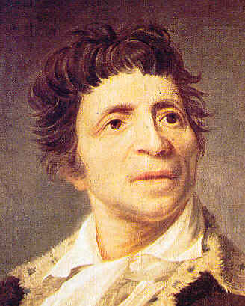
Jean Paul Marat
Marat was born in Boudry, Switzerland but had the French nationality.
Marat's Education: At 16 years old, Marat left his parents to study medicine in France and later, in England. He was a pretty renowned scientist; he worked on physics and published some of his works on energy from fire and on electricity.
His work was criticized by the French famous "Academy des Sciences" and his membership to the famous institution was rejected several times.

Marat became journalist: The political events in France and more particularly the opening of the General Estates, gave Marat the opportunity to express his disapproval of the regime in another way. He became a journalist with radical ideas when other newspapers published still very liberal points of views. In September 1789, he started his own newspaper "L'ami du peuple" ("Friend of the people") where he attacked the enemies of the Revolution. The French crowd was fond of these articles where the conservatives are criticized at every level of the French society, even inside the "Tiers-Etats".

Marat's Extremism: On July 14th, 1789 at the Storming of the Bastille, Marat declared that five to six hundreds heads should be cut in order to install a new regime. His goal was to eliminate all the people near or far related to the king. In 1792, he talked about his wish to see a new dictatorship installed where the true values of the Revolution will be implemented. His extremist ideas were accused to have led to the massacre of September 1792.

Marat's Political Ascension: That same month, Marat was elected to the National Convention where he sat with the "Montaguards". He renamed his famous newspaper to "le journal de la republique francaise" (the journal of the French republic).
In 1793, he was elected president of the Jacobins club and asked for the destitution of the Girondins, whom he believed were enemies of the republicanism. On the other side, the Girondins attacked the dictatorship of the Montaguards and their famous leaders, Robespierre, Danton and Marat. The battle between to two parties ended on June 2nd, 1793. The Convention decided to eliminate the Girondins. This was a very important victory for Marat, who became even more popular.
On July 13th, 1793 Marat was murdered by Charlotte Corday, a Girondin sympathiser.
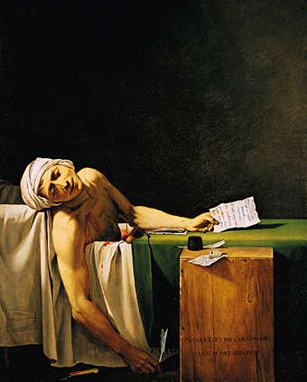
Jean Paul Marat's death illustrated by Jacques Louis David (1793)
The Republic gave him a national honor with grandiose funeral. On his tombstone was engraved these words, "Here sleeps Marat, the friend of the people who was killed by the enemies of the people on July 13th, 1793".
On September 21st, 1794 Marat was officially declared an "Immortel" and exhumed to the Pantheon.

