Historical Figure - Impact upon the World
In your opinion, who had the biggest impact upon the world?
King Henry VIII | Queen Elizabeth
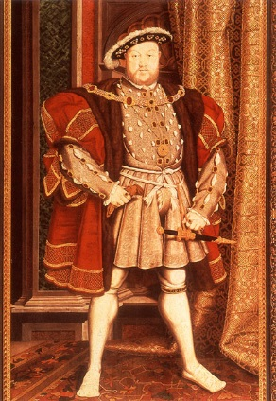 | 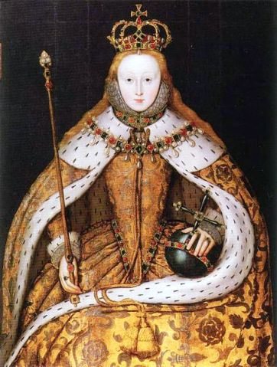
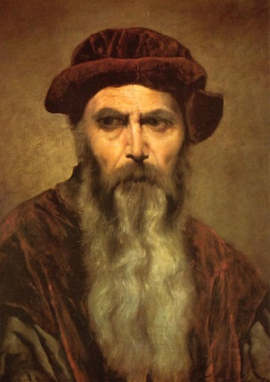 | 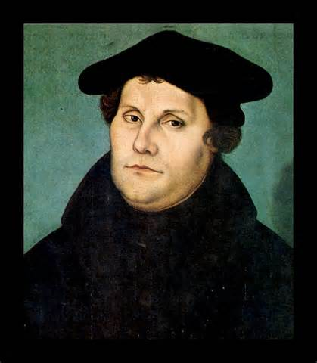
Johann Gutenberg | Martin Luther

TWO pieces of EVIDENCE to support your claims:
1.)________________________________________________________________________________________________________________________________________________________________________
2.)________________________________________________________________________________________________________________________________________________________________________

__________________________________________________________________________________________________________________________________________________________________________________________________________________________________________________________________________________________________________________________________________________________________________________________________________________________________________________________________________________________________________________________________________________________________________________________________________________________________________________________________________________________________________________________________________________________________________________________________________________________________________________________________________________
_________________________________________________________________________________________________________________________________________________________________________________________________________________________________________________________________________________________________________________________________________________________________________________________________________________________________________
_________________________________________________________________________________________________________________________________________________________________________________________________________________________________________________________________________________________________________________________________________________________________________________________________________________________________________
_________________________________________________________________________________________________________________________________________________________________________________________________________________________________________________________________________________________________________________________________________________________________________________________________________________________________________
_________________________________________________________________________________________________________________________________________________________________________________________________________________________________________________________________________________________________________________________________________________________________________________________________________________________________________
__________________________________________________________________________________________________________________________________________________________________________

