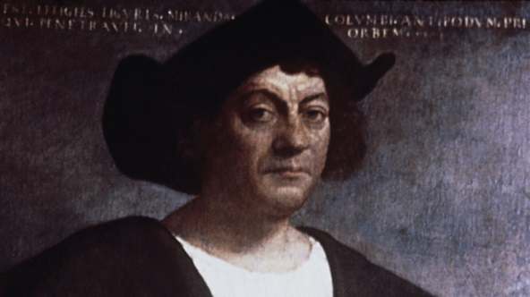
Three countries refused to back Columbus’ voyage. Name 2!
For nearly a decade, Columbus lobbied European monarchies to bankroll his quest to discover a western sea route to Asia. In Portugal, England and France, the response was the same: no. The experts told Columbus his calculations were wrong and that the voyage would take much longer than he thought. Royal advisors in Spain raised similar concerns to King Ferdinand and Queen Isabella. Turns out the naysayers were right. Columbus dramatically underestimated the earth’s circumference and the size of the oceans. Luckily for him, he ran into the uncharted Americas.

Which of Columbus’s ships was nicked “prostitute” or “Painted one?”
In 15th-century Spain, ships were traditionally named after saints. Salty sailors, however, bestowed less-than-sacred nicknames upon their vessels. Mariners dubbed one of the three ships on Columbus’s 1492 voyage the Pinta, Spanish for “the painted one” or “prostitute.” The Santa Clara, meanwhile, was nicknamed the Nina in honor of its owner, Juan Nino. Although the Santa Maria is called by its official name, its nickname was La Gallega, after the province of Galicia in which it was built.
Which of the three original ships wrecked?
On Christmas Eve of 1492, a cabin boy ran Columbus’s flagship into a coral reef on the northern coast of Hispaniola, near present-day Cap Haitien, Haiti. Its crew spent a very un-merry Christmas salvaging the Santa Maria’s cargo. Columbus returned to Spain aboard the Nina, but he had to leave nearly 40 crewmembers behind to start the first European settlement in the Americas—La Navidad. When Columbus returned to the settlement in the fall of 1493, none of the crew were found alive.

How many voyages did Columbus make to the ‘New World’?
Although best known for his historic 1492 expedition, Columbus returned to the Americas three more times in the following decade. His voyages took him to Caribbean islands, South America and Central America.

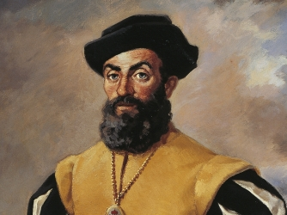
While anchored near modern-day Argentina, Magellan’s men reported encountering 8-foot-tall men on the beaches of Patagonia. After befriending these “giants,” Magellan supposedly tricked them into boarding his ship and took one of the men captive. The giant was later baptized and named Paul, but died during the fleet’s long crossing of the Pacific Ocean.

One of the most important members of Magellan’s voyage was his personal slave Enrique, who had been with the captain since an earlier voyage to Malacca in 1511. As many historians have noted, if Enrique was originally from that part of the world, then by the time the expedition reached the Philippines he would have already circled the earth and returned to his homeland. If true, this would mean the slave Enrique—rather than any of the European mariners—was the first person to circumnavigate the globe.
After weathering horrific storms near southern South America and losing one of his ships to rough seas, Magellan finally entered what is now known as the Strait of Magellan in November 1520. Crossing into a calm and gentle ocean, he named it “Mar Pacifico,” which means “peaceful sea” in Portuguese. Magellan believed that he would quickly reach the Spice Islands, but his beleaguered fleet would sail the Pacific Ocean for 98 days before reaching any habitable land.
Magellan’s mostly Spanish crew resented the idea of being led by a Portuguese captain, and the expedition was forced to weather two mutinies before it had even reached the Pacific. The first of these failed revolts was easily unraveled, but the second proved more elaborate. Worried that Magellan’s obsession with finding passage to the Pacific was going to doom the expedition, in April 1520 three of his five ships turned against him.
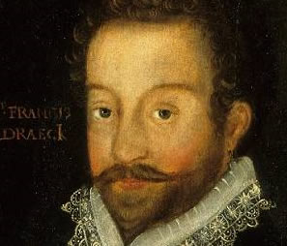
Sir Francis Drake had a wife but no kids. His last voyage was in 1596. He died from a high fever, after losing a battle against Puerto Rico. His crew decided to bury him at sea.

The English might have loved the exploits of Sir Francis Drake, but the Spaniards hated the man with a passion. King Philip II of Spain at one point even offered a reward that in today’s money would equal about $6.5 million in order to capture Drake dead or alive.
Why was he so hated? Because Drake was more of a pirate than a soldier. When there was a battle at hand, Drake would go plunder possessions while other ships engaged in battle.
So rich was Drake that one of his earlier voyages in the 1570s was self-funded.

Many of the jewels and tokens of note from the colonial era have either gone missing or dropped into private collections that no one really talks about. One of the great exceptions to this is the Drake Jewel, which Queen Elizabeth gave Sir Francis Drake after his around the world journey was completed. As a commoner, the gift was unusual enough in itself. The fact that it held an official portrait of the queen and a cameo of a dual portrait on the reverse make it even more unusual. You can see this gift today at the Victoria and Albert Museum
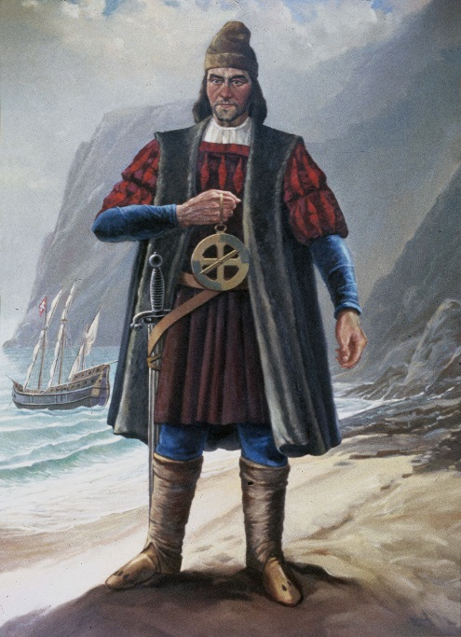
Dias himself was put in charge of four ships, which traveled first to Brazil, reaching it in March 1500. From there, a course was set for South Africa and then India. Dias, however, was never to see the land he had tried for so long to reach. In May, as the ships rounded the Cape, four of the 13 ships were sunk in a storm, with.Dias among those who drowned.
Born in 1450, Bartolomeu Dias was sent by Portuguese King John II to explore the coast of Africa and find a way to the Indian Ocean.
Dias named the tip of Africa ‘Cape of Storms' because of the storm they had encountered when they first sailed past it.
The king of Portugal changed the name to the ‘Cape of Good Hope' because he believed that its discovery would eventually lead to a route to India via water.

Bartolomeu Dias was the first European explorer to sail around the southern tip of Africa discovering what is called the Cape of Good Hope

