Comic book illustrations of a Greek Myth
Circe the Beautiful Witch Cyclops Cave The Midas Touch Orpheus
Intro – set the stage | Significant event | Significant event | Significant event | Conclusion
The Homecoming of Odysseus
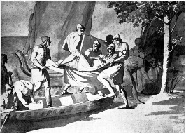  Odysseus arrives in Ithaca – as a beggar | His wife, Penelope has been stalling suitors  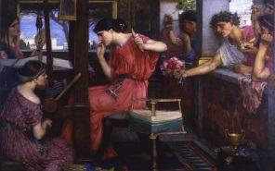 | Odysseus’s and his son Telemachus hatch a plan!  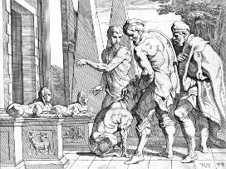 | Penelope says an archery contest will decide!  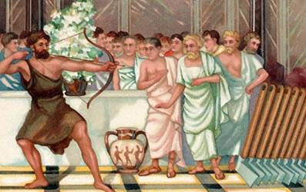 | Penelope tests Odysseus and they are reunited!  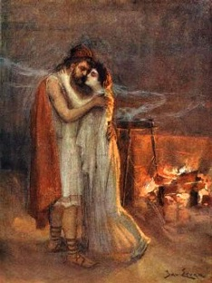

Comic book illustrations of a Greek Myth
Circe the Beautiful Witch Cyclops Cave The Midas Touch Orpheus
Intro – set the stage | Significant event | Significant event | Significant event | Conclusion
The Homecoming of Odysseus
Odysseus arrives in Ithaca – as a beggar | His wife, Penelope has been stalling suitors | Odysseus’s and his son Telemachus hatch a plan! | Penelope says an archery contest will decide! | Penelope tests Odysseus and they are reunited!

