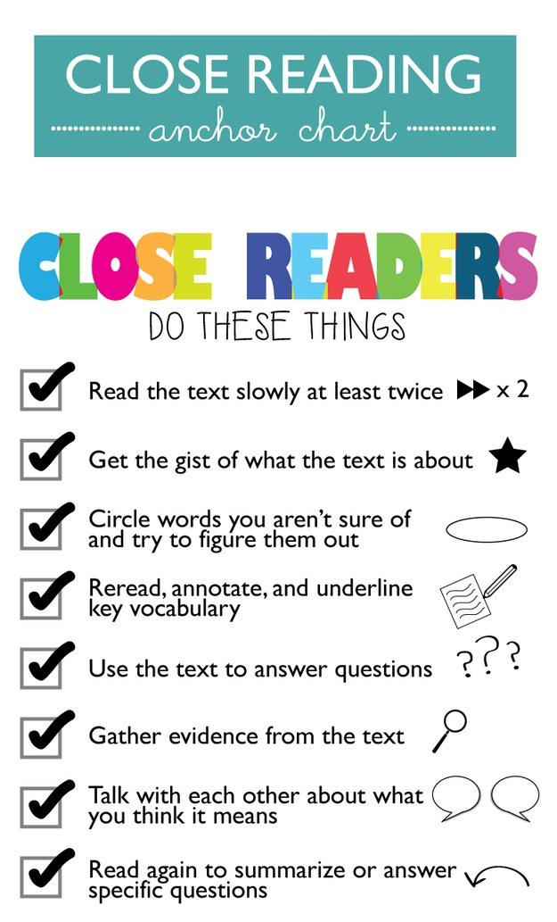
…………………………………………………………………………………………………………………………………………….
Socratic Seminar Rubric/Class Discussion
 | Foundational | Developing | Proficient | Score
Has prepared by critically engaging with the material. | Highlighting is obvious. | In addition to highlighting, words are circles, some annotations. | Highlighting, annotations and questions posed.
Asks a higher level questions (can’t be answered in yes/no). | Does not ask a high level question. | Attempts to ask a higher level question, but may not provoke thought or stimulate deeper discussion. | Appropriately asks a high-level question that provokes thought and stimulates deeper discussion.
Refers to the text and/or another student’s ideas | Rarely, never refers to the text or another student’s ideas. | Sometimes refers to the text or another student’s ideas. | Routinely refers to the text or another student’s ideas.
Offers a useful comment, a connection, or an insight | Rarely/never offers a useful comment or make a connection. | Sometimes offers a useful comment or makes a connection. | Routinely offers a useful comment or makes a connection.
Points 0 – 1 Points 2-3 Points 4

